Assignment After doubt Session Dt: 26-05-2026 - Topic: Java Basic Programs
- Print Hello World
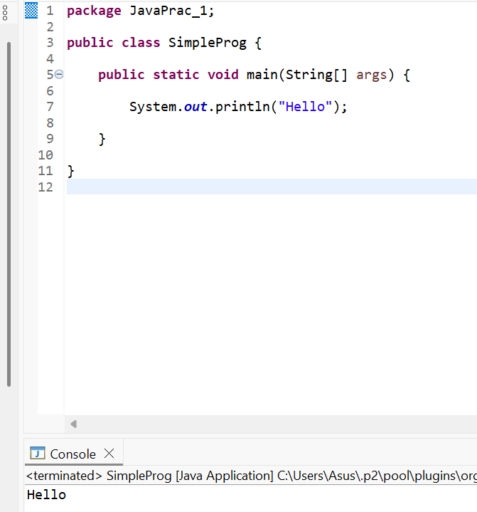
2. Check even or odd
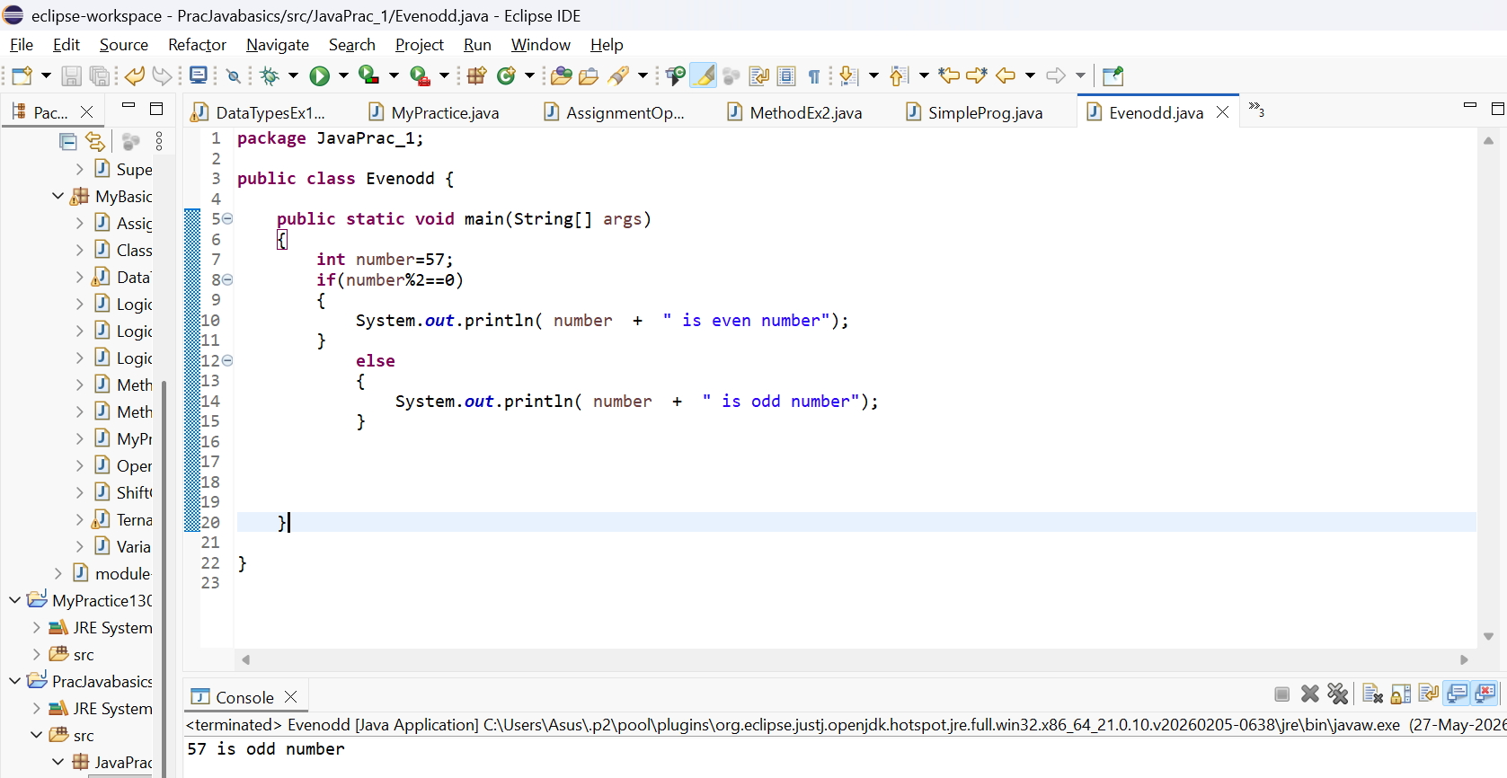

- Check positive / negative / zero
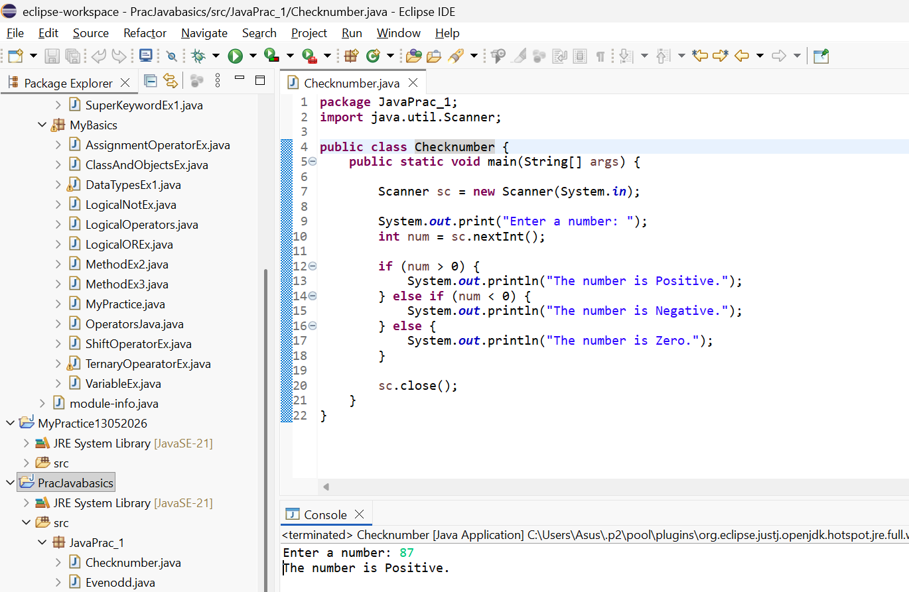
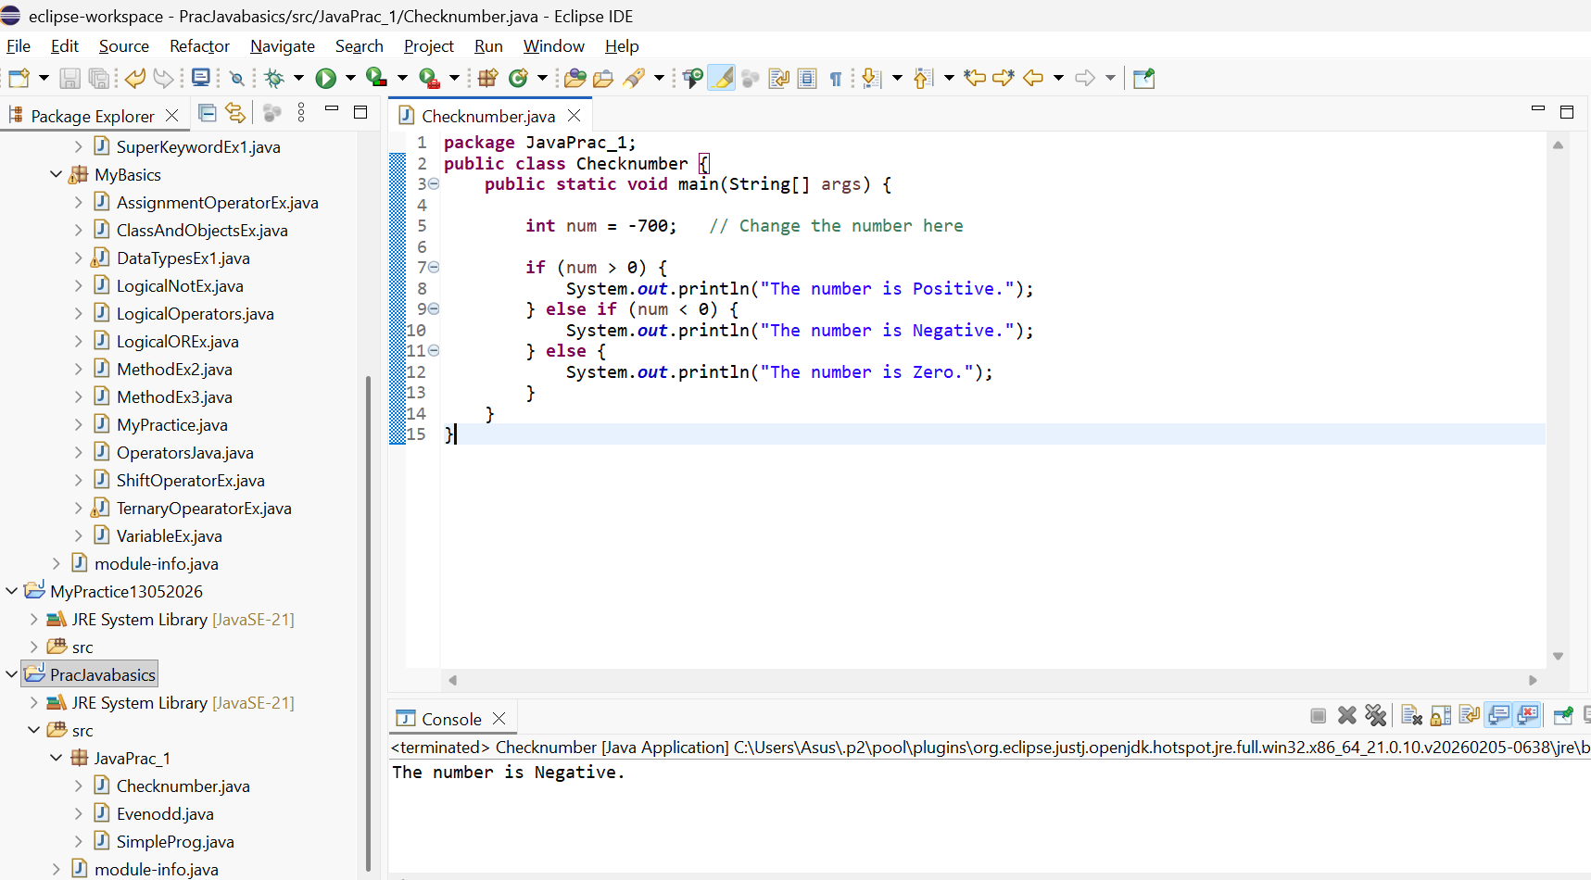
- Swap two numbers (with & without third variable)
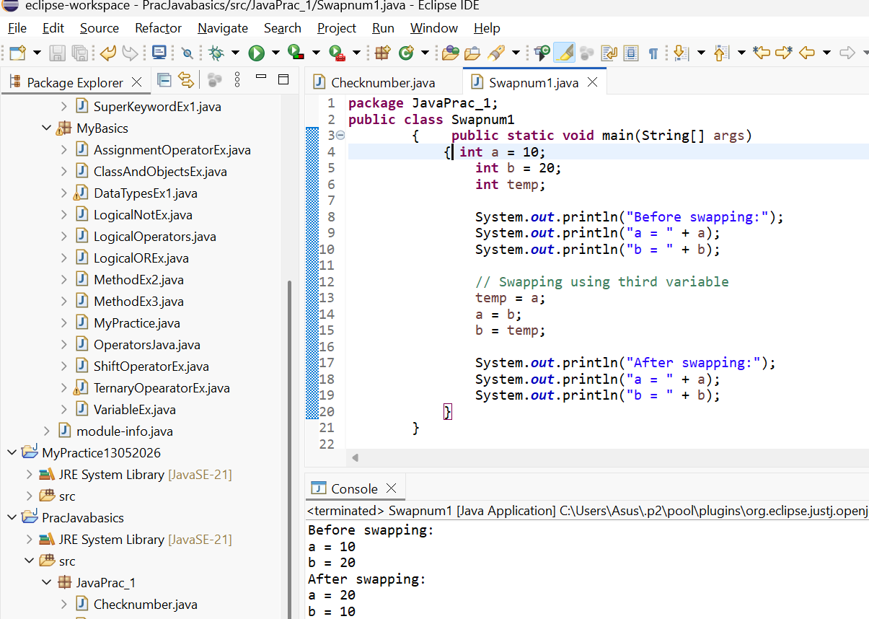

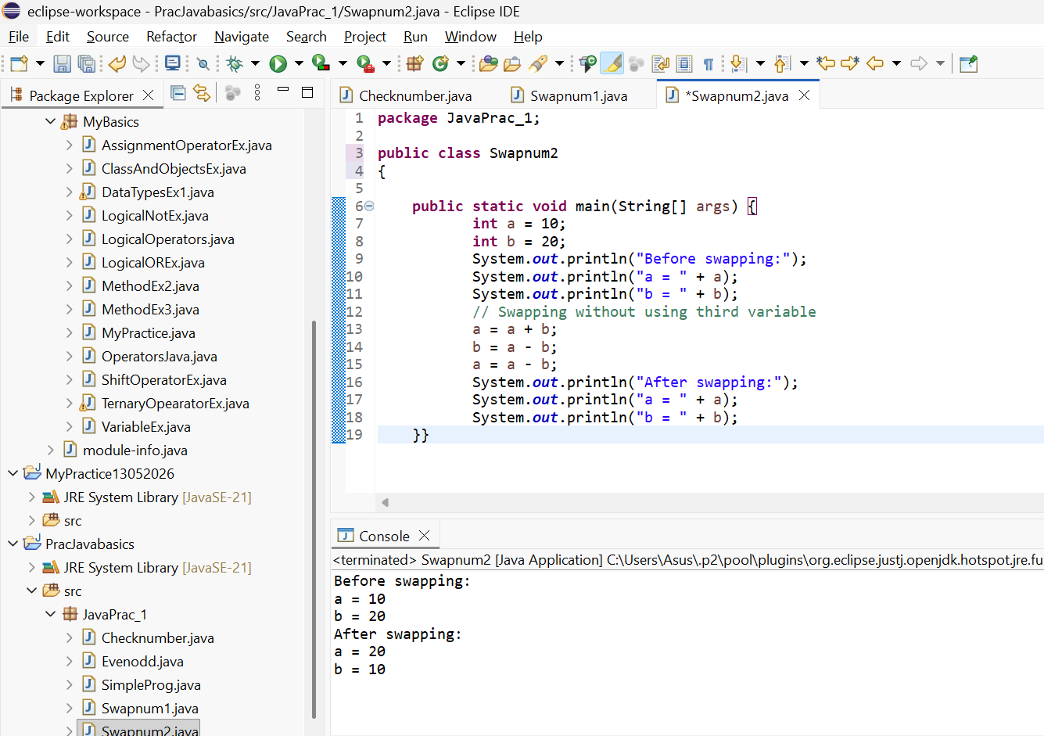

- Find largest of 3 numbers
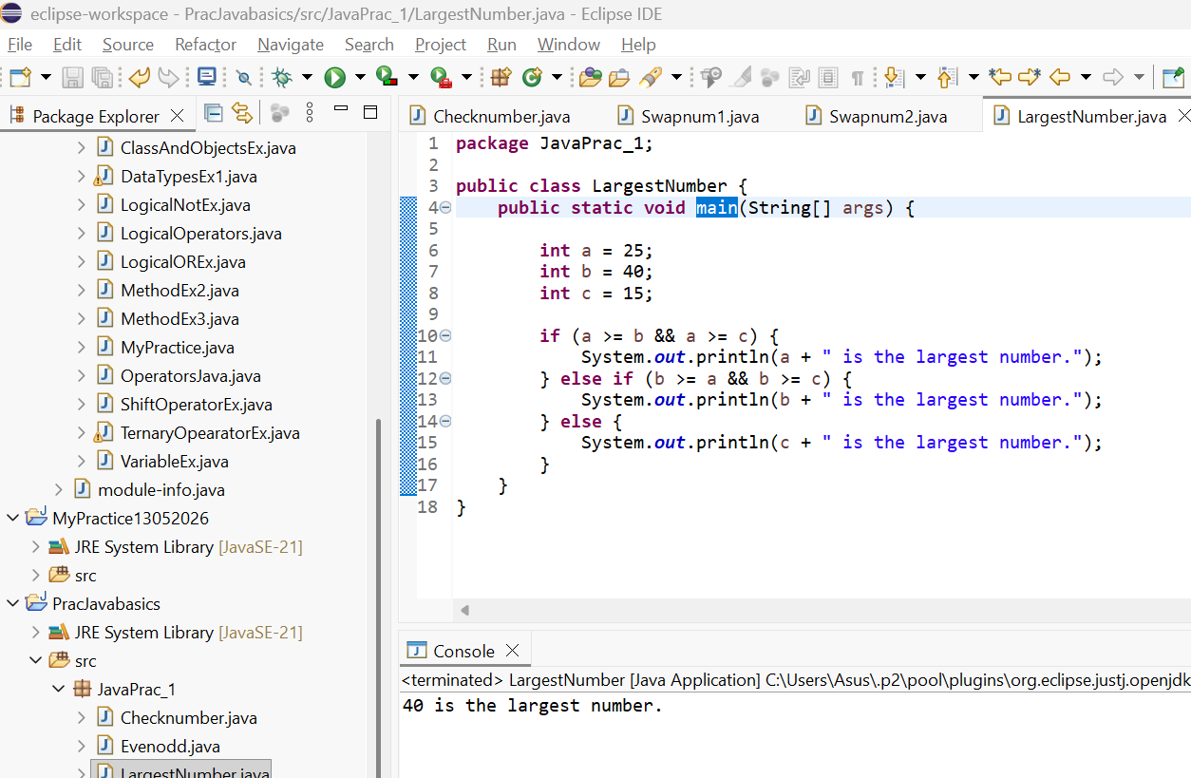
- Multiplication table of a number
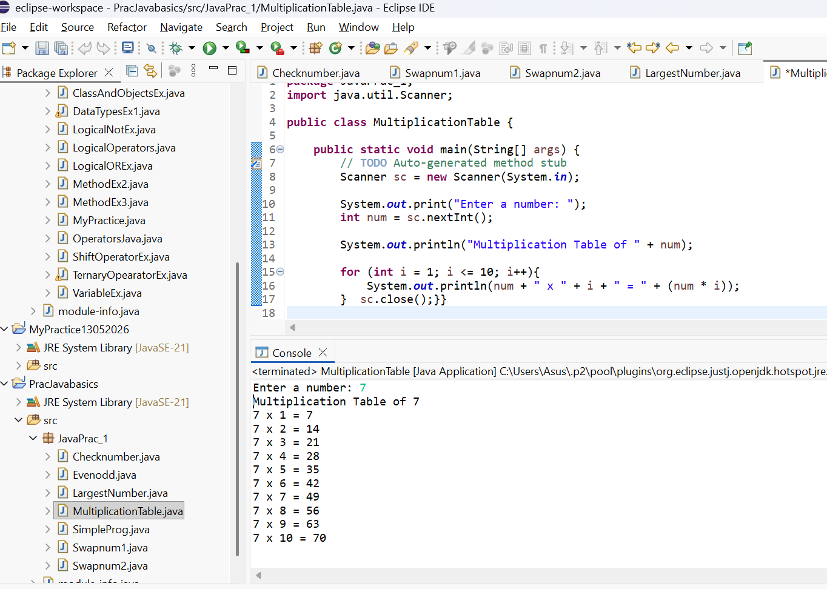

- Reverse a number
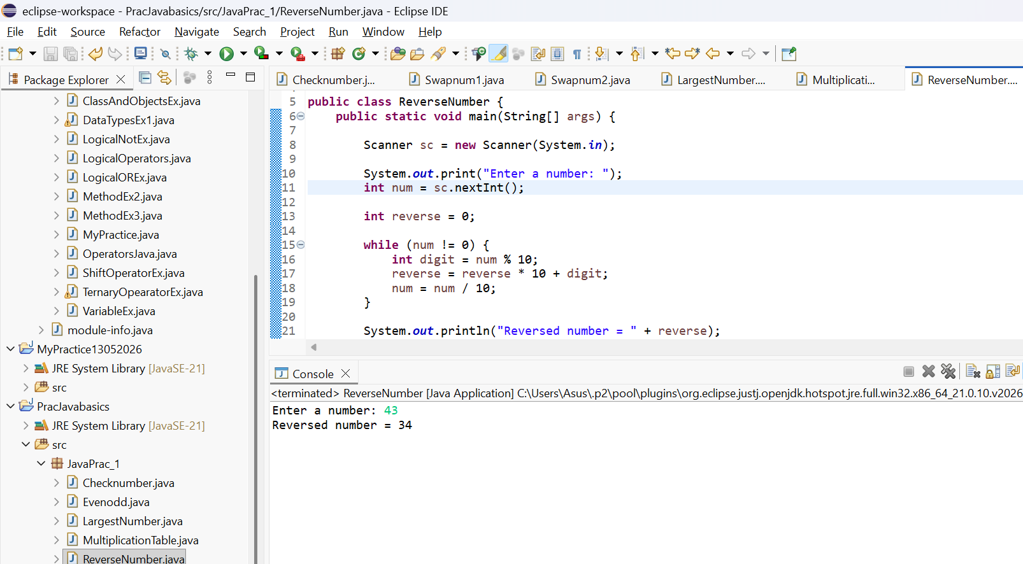
- Check palindrome number
- package JavaPrac_1;

- import java.util.Scanner;

- public class PalidromeNumber {
- public static void main(String[] args) {

- Scanner sc = new Scanner(System.in);

- System.out.print("Enter a number: ");
- int num = sc.nextInt();

- int original = num;
- int reverse = 0;

- while (num != 0) {
- int digit = num % 10;
- reverse = reverse * 10 + digit;
- num = num / 10;
- }

- if (original == reverse) {
- System.out.println("Palindrome Number");
- } else {
- System.out.println("Not a Palindrome Number");
- }

- sc.close();
- }
- }
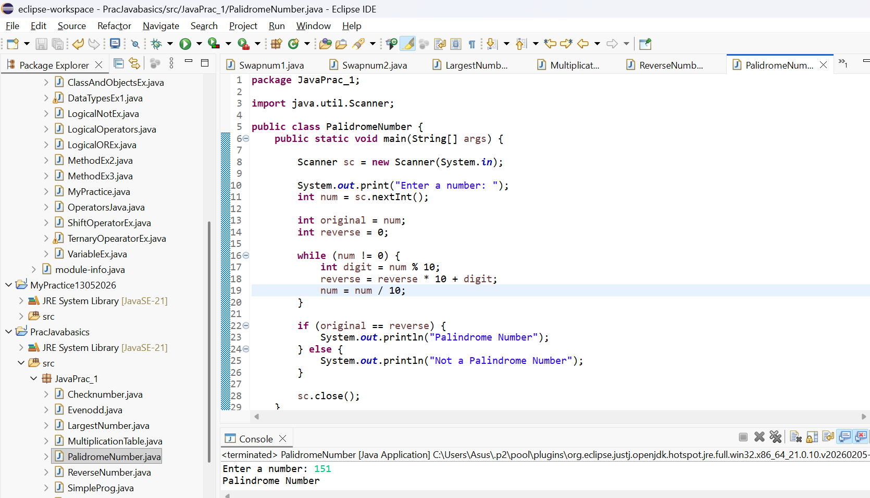

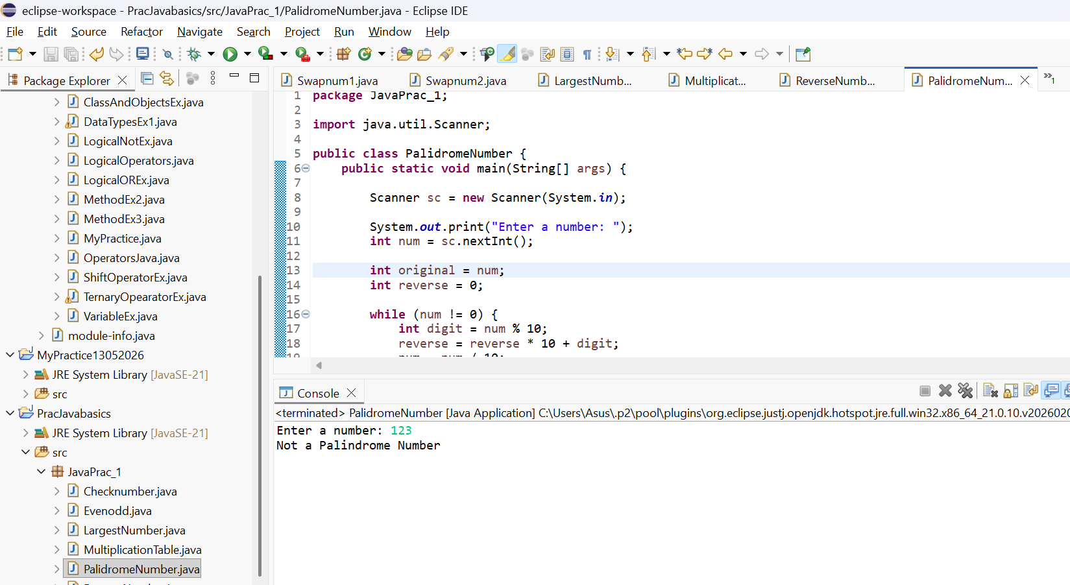
9. Check prime number

10. Print Fibonacci series
